REPORT

Enterprise Programming

Joe Allen (20097029)

Design Patterns

I have used a singleton pattern when instantiating my filmDAO objects. I did this because there was no need to create more than one in order for it to serve its purpose (to give access to database operations using JDBC). The constructor in my filmDAO class was made private, and instantiated as seen below:



Setting it up like this saves the CPU space that would be required if I were to create a new filmDAO object each time it was required. I used the filmDAO within each servlet method and accessed the relevant method(s) based on the nature of the request i.e. doGet uses getAllFilms(), getFilmByID() and getFilmByName().

Furthermore, I have used Data Transfer Objects (DTOs) to simply hold data within my project, for example when creating film objects.

Here, I am using the ‘this’ keyword within the constructor to make establishing Film objects straightforward; by passing in the attributes as parameters.

I have made use of getters and setters for each attribute to function as accessors to film data upon request.

Another design pattern I made use of within the project is connection pooling. This allowed me to find a connection to my database, stored on Mudfoot, through the use of a connection URL, the database credentials and the JDBC connection driver.

Refactoring code is increasingly important as the scale of a project increases, with the increased memory usage. I have refactored my code to combat this by making use of functions for operations that are regularly repeated. A good example of this would be where I have used a modal to display a ‘loading’ message to the user. I have created a ‘closeLoadingModal()’ to save writing the same lines of code over and over again.

RESTful Web Service

I used the jQuery and Bootstrap libraries in CSS/JavaScript to provide more functionality and design features. jQuery has allowed me to access event listens and interact with html elements i.e. removeClass, setting display, updating values etc, as well as the ability to make AJAX requests which I used when obtaining film objects to display in forms (i.e. the ‘update film’ form already containing the previous values.)

Here is an example of a modal I have used. The ‘modal fade’ class gives the modal a fade transition onto the page. The content of the form is contained within the body, with action buttons in the footer.

Here is a modal I created to display a success message upon completion of an operation. The default message within modal-body is changed using JavaScript if this modal is used for something else i.e updating a record or deleting.

This is a modal that displays a spinner wheel to communicate to the user that the resource is loading, whilst the request happens in the background. The “spinner” class comes from the Bootstrap library.

**JavaScript**

This method initialises the address and format parameter for a GET request, submits request using ajaxResult method then uses a responseHandler to run the correct method based on the format the user selected.

ajaxResult initiates a GET request to the server, passing the desired data format in the “Accept” header.

The ‘findHandler’ method takes the format and returns the method to be used to construct the data in that format.

JAXB is used to convert the list of Film objects into an XML structure. Using a library like this or GSON for JSON format allows complex operations to be performed with a few lines of code and saved me from having to write the functions manually.

Similarly to XML, I used the GSON library to convert Film objects to a JSON format:

For data in string format, I used “rawData.split(‘\\n’)” to separate each film object, and then used the # symbol as a delimiter to split each attribute.

Sets the headings of the table:

Initialises the film table:

Inserts data into a html element i.e. film table, textbox values for update form etc.



Establishes conditions of POST request, sets parameters etc.

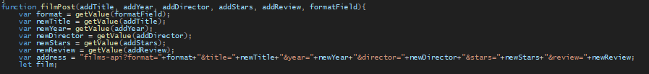

Validation of user inputs:

If all the validation tests are passed, open POST request:

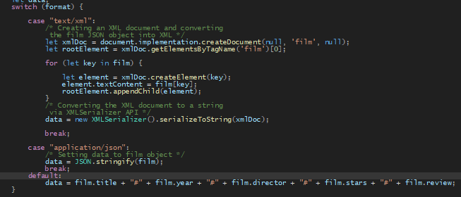Switch statement determines how the data returned by the server is formatted:

If HTTP request returns status code 200 & readyState of 4, remove pre-existing tables and display/remove modals. If request returns an error, alert the user.

filmPut method – sets up address and parameters for a PUT request:

Validation checks for PUT request. If passed, create a Film object, and pass it to ajaxPut:

Similarly to ajaxPost, ajaxPut converts the film object into the relevant format (XML, JSON, String) to send to the server.

If request is successful, show success message and clear the form. If not, alert the user.

Method to initiate DELETE request

Opens DELETE request, success modal displayed upon correct network response:

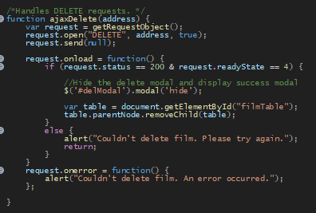

This method gets the browser-specific request object, and covers all browsers (Internet Explorer 5 and 6 covered in the ‘else if’ statement:

The following method uses jQuery to listen for a search request using ID. A GET request is made within the corresponding function to return a film object if the entered ID can be matched to one. If a record is found, a new table is created containing the record. If not, the user is alerted.

A similar search function, but for searching by film title as opposed to the ID. This is important because the title of a film is memorable unlike its ID number which is exclusive to this dataset.

NETWORK REQUESTS:

GET

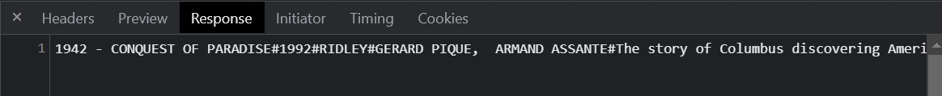

POST

PUT

GET request made initially to obtain current film data;

Parameters in URL (Bad practice – definitely a shortcoming)

DELETE

Same as with PUT, a GET request is made to get the film name for display purposes

POSTMAN screenshots

GET - XML

GET - JSON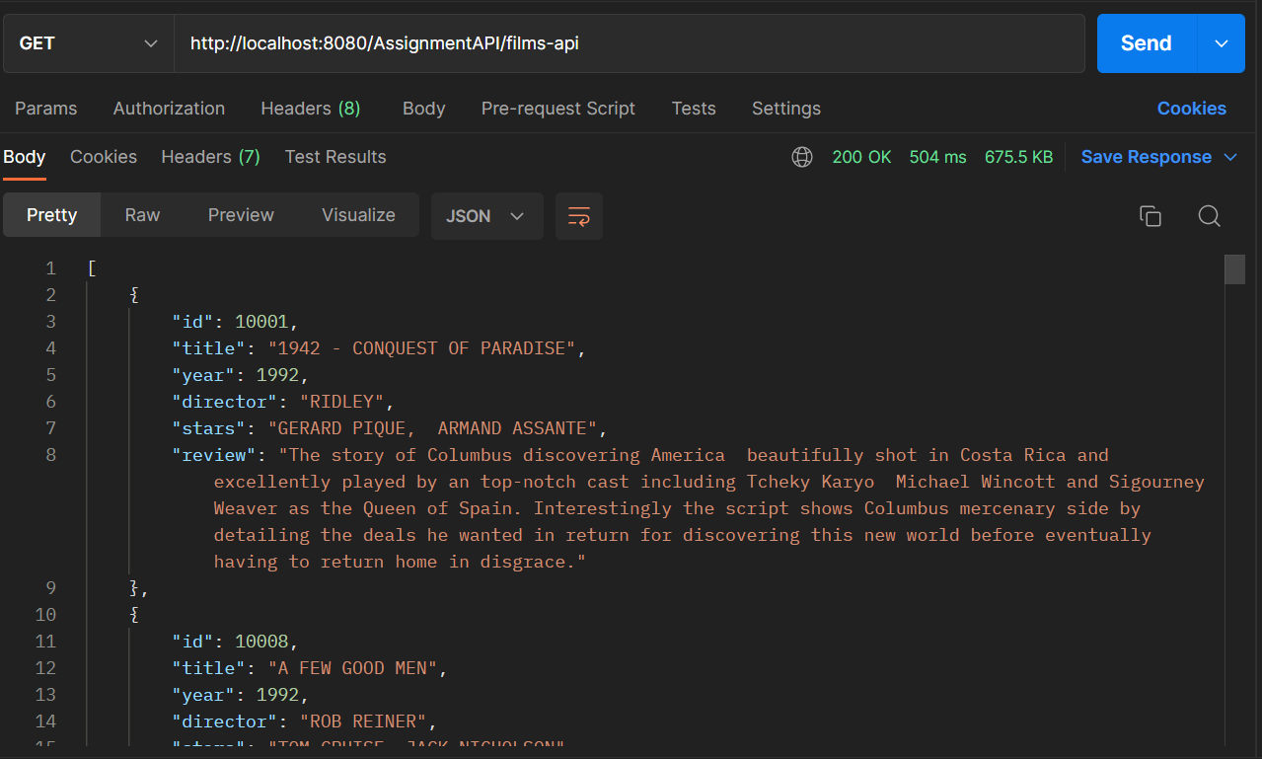

GET - STRING

POST

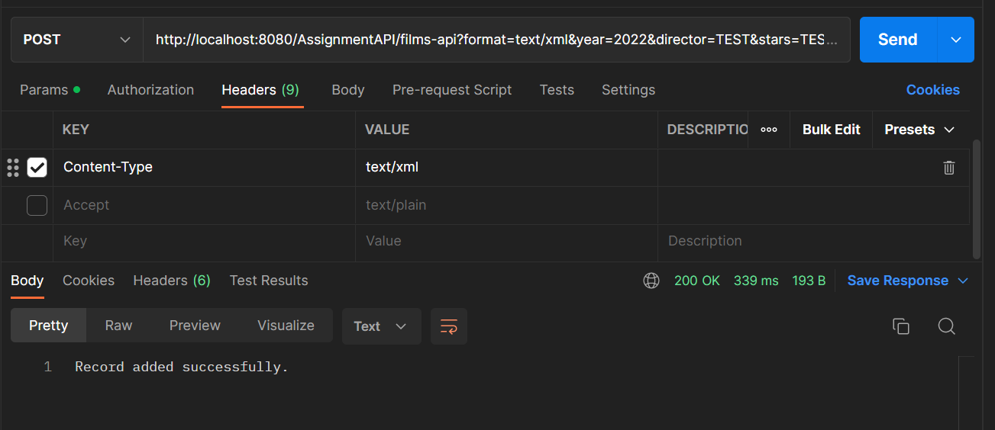

DELETE

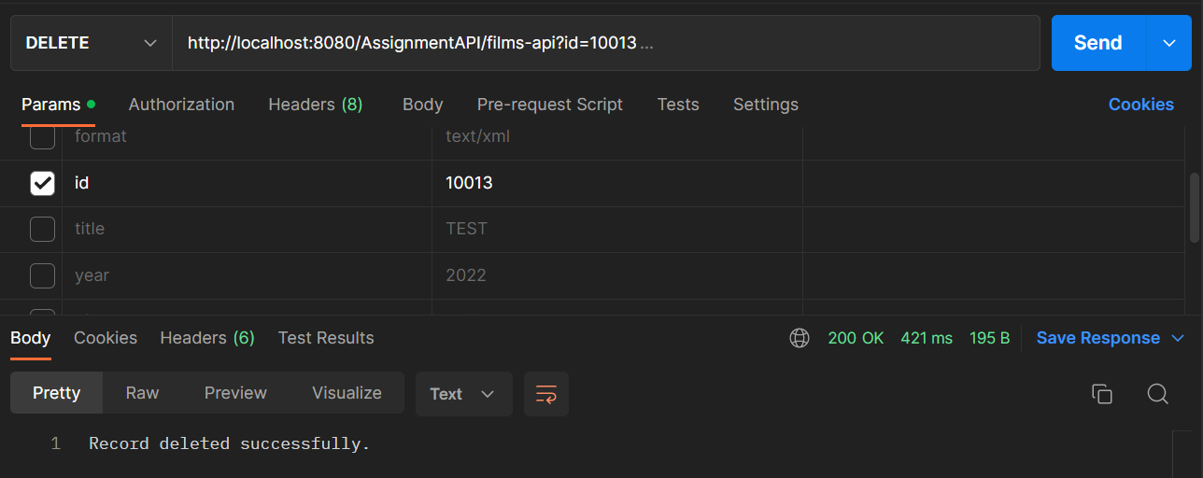

FRONT-END

“Add Film” modal:

“Update film” modal:

“Delete film” modal:

Search by ID – modifies the table to show the matching record:

Search by title – modifies the table to show records with a matching substring:

FilmDAO

Establishing database connection using JDBC driver and connection url + credentials:

Gets the next film in a resultSet:

Gets ALL films:

Search using ID:

Search by title:

Inserts new film:

Updates an existing film using ID:

Deletes film:

Cloud Implementation

After many hours of messing about with various errors trying to set my database up with AWS, from “incorrect driver used” to “incorrect character set index” I did not have enough time to fix the problems and get it up and running. The process was more complicated than I thought it would be, and I should have allocated more time to get this up and running.

MVC Application

HomeController – displays “home.jsp” page:

Home.jsp – uses JSTL and Java beans to inject film records onto the page in a table.

InsertController – doGet loads Insert.jsp, doPost gets Film object and inserts into the database.

Insert.jsp

UpdateController – similar to InsertController but includes ID within film object:

Update.jsp – uses JSTL + JBeans to display data about the film being updated. This saves the user from re-entering data = user-friendly

DeleteController – doGet retrieves film data to display in Delete.jsp page, doPost takes ID parameter, conducts deletion, and redirects the user to the homepage.

Delete.jsp – carries ID value through a hidden element to be accessed in the DAO.

FilmDAO – All the same methods as the DAO used in the RESTful web service, apart from getFilmByTitle(), which does not exist in the MVC.

Challenges faced:

Throughout the course of this project, there have been many challenges encountered. I would say the biggest challenge has been the complexity but also the depth of the material that we have learnt. I have personally found it a challenge to come in each week and grasp the topic of that week straight away meaning that I have had to go back through a lot of the content during the creation of the assignment to refresh my knowledge. As a result, there was a lot of back and forth and less time spent strictly on implementing code to fulfil the objectives, which has been disrupting. However, I know that with repetition comes experience and knowledge, and I hope that when it comes to working on web projects in the future, the groundwork that has been done during this project will be put to use. I have certainly learnt the foundational knowledge of web services by using HTTP requests and servlets for the first time, along with the anatomy of network requests and how data can be sent in different formats from client-to-server and vice versa.

Secondly, a good portion of my development has come from my own research which has meant learning completely new concepts, for example the use of Bootstrap to use modals in my JSP page and the jQuery library in JavaScript. There was a lot of trial and error whilst learning, which evaluated my perseverance and became time consuming. It came to significant effect, however, as it made using JavaScript a lot simpler due to the quick and easy manipulation of DOM elements that jQuery offers.

There were some things I tried to do that I failed to be able to implement due to the complexity or because I managed my time poorly and did not leave enough time to play around and try to solve any issues. For example, I tried to implement the DataTables plugin for jQuery to add filtering and pagination to my film table. I tried as many different ways as possible to make it work but it proved more difficult than first seemed and was more of a desirable feature than a compulsory one, so I decided against using it. Another example was trying to set up my database on the cloud. Dealing with the aforementioned complications when doing this proved too time-taxing with the time I had left. I even tried multiple platforms: first with Google Cloud and then AWS, but each had their own complications which I could not justify trying to fix when I still had bits of key functionality to work on.

Future Work

I plan to continue working on this assignment past this unit as it is something that can be used in my portfolio when applying for roles in the industry. Here is a list of the improvements I plan to make:

* Make the database live on the cloud through AWS/Google Cloud
* Improve the security of my HTTP requests by including data in the body of the request rather than the URL
* Make the table more interactive and user-friendly by using an API like DataTables
* Add a ‘rating’ column that shows an average star rating
* Add user functionality to allow for publicly accessible reviews
* Add a ‘genre’ column and allow searching by genre
* Searching & sorting by star rating, genre, title, year
* Make design improvements to page structure, colour scheme etc.